**Demonstrate how Selenium web driver is installed and integrated in Eclipse.**

[Selenium](https://www.browserstack.com/selenium) is the most popular automated tool in existence today. [59.5%](https://www.selenium.dev/blog/2021/selenium-survey-results/) of people consider [Selenium for](https://www.browserstack.com/guide/cross-browser-testing-in-selenium)Cross Browser Testing because of the robustness and flexibility it offers by supporting multiple languages like Java, C#, Python, Perl, Ruby, etc. However, a majority ([67%](https://www.selenium.dev/blog/2021/selenium-survey-results/)) of the Selenium users prefer Java as their language for Selenium Testing.

This article discusses how to configure Selenium in Eclipse to use [Selenium for Java](https://www.browserstack.com/guide/selenium-with-java-for-automated-test).

**Prerequisites for configuring Selenium in Eclipse**

* [Install Java](https://www.oracle.com/java/technologies/javase-jdk16-downloads.html)Download Java SE Development Kit 16.0.2 according to the Windows, Linux, or macOS platform being used.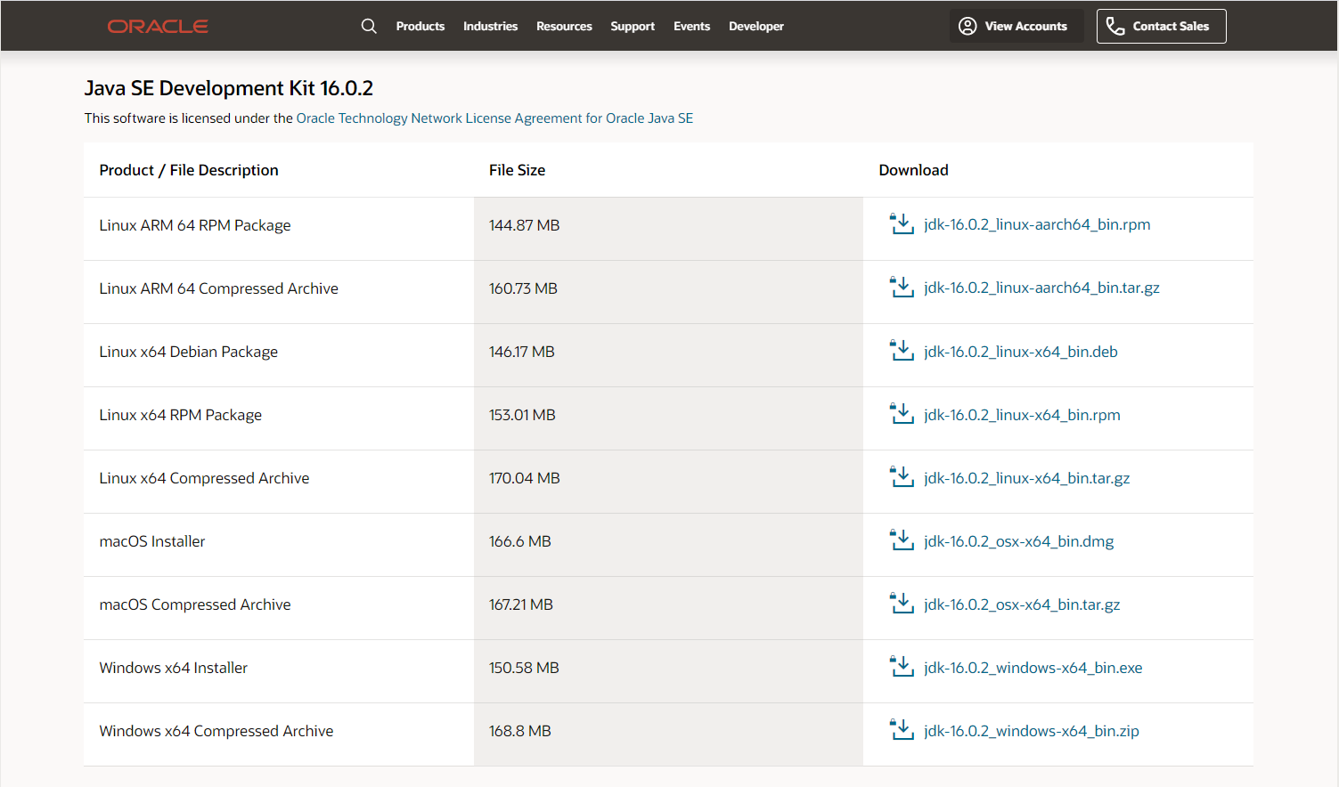

[Source](https://www.oracle.com/java/technologies/javase-jdk16-downloads.html)Run the JDK Installer by double-clicking on the file name in the download location and following the instructions on the instruction wizard. Alternatively, silently install JDK by entering the following command:

jdk.exe /s

[Install Eclipse IDE](https://www.eclipse.org/downloads/)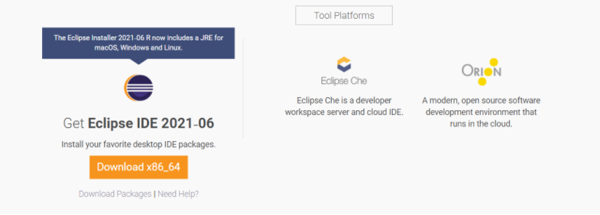  
[Source](https://www.eclipse.org/downloads/)

[Install Selenium](https://www.selenium.dev/downloads/)

Download and Install Selenium to be set up in Eclipse.

Install Browser Driver

For [Cross Browser Testing](https://www.browserstack.com/live), download the relevant Browser Driver – [ChromeDriver](http://chromedriver.chromium.org/) (for Chrome), [GeckoDriver](https://github.com/mozilla/geckodriver) (for Firefox), [SafariDriver](https://developer.apple.com/documentation/webkit/testing_with_webdriver_in_safari)(for Safari), and [InternetExplorerDriver](https://github.com/SeleniumHQ/selenium/wiki/InternetExplorerDriver) and [MSEdgeDriver](https://developer.microsoft.com/en-us/microsoft-edge/tools/webdriver/) (IE and Edge respectively). Place these Browser Driver files in a directory that is part of the environment PATH. This will allow a command-line call to the programs to execute them irrespective of the working directory.

Install Java Language Bindings

[Version 3.141.59 (2018)](https://github.com/SeleniumHQ/selenium/releases/download/selenium-3.141.59/selenium-java-3.141.59.zip)

[Changelog](https://github.com/SeleniumHQ/selenium/blob/trunk/java/CHANGELOG)

[API Docs](https://seleniumhq.github.io/selenium/docs/api/java/index.html)

How to configure Selenium in Eclipse

Here are the steps to configure Selenium Webdriver with Eclipse:

Step 1: Launch Eclipse

To launch Eclipse double click on the eclipse.exe file in the download location.

Step 2: Create Workspace in Eclipse

This workspace named “C:\BrowserStack” is like any other folder, which will store all the test scripts. Launch the BrowserStack workspace.

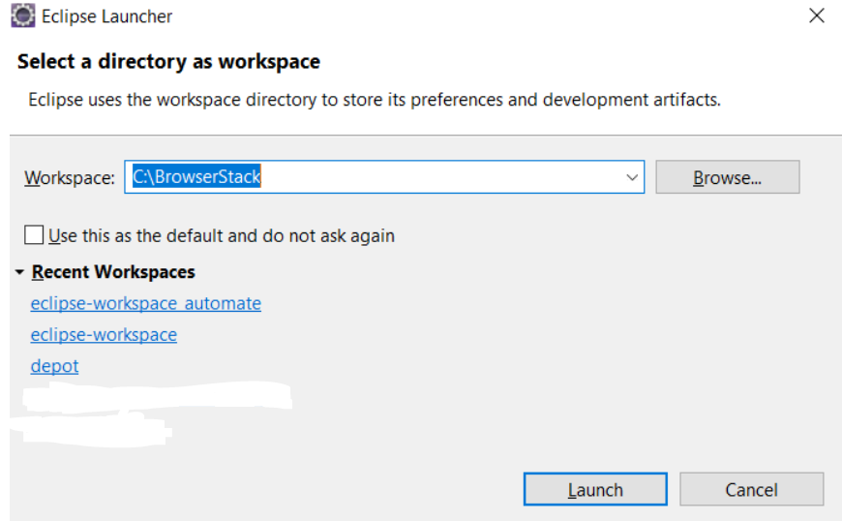

Creating Workspace in Eclipse

Step 3: Create New Java Project in the BrowserStack Workspace

Create a new Java Project by clicking on File > New > Java Project and name it.

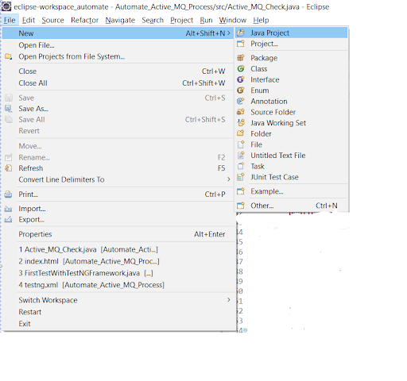  
Creating a new Java Project

Step 4: Create Package and Class under the Java Project

By clicking on the src folder (which is the source folder), create a new package and name it (BrowserStack). Then right-click on the package name and create a class.

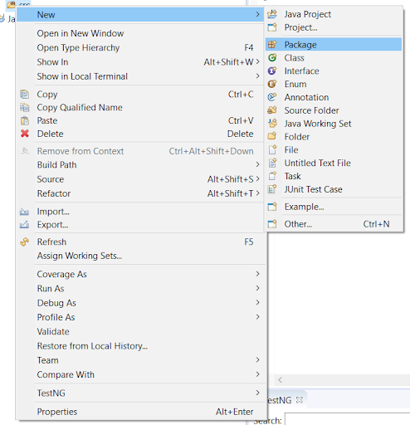

Creating Package in the Java Project

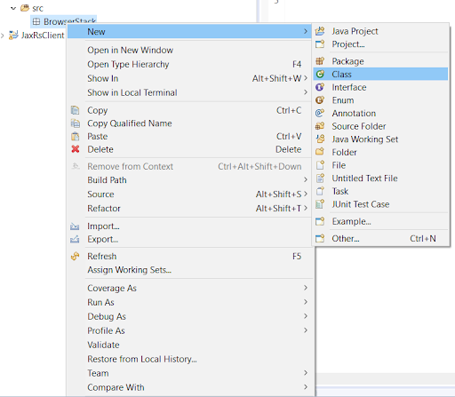  
Creating Class in the BrowserStack Package

Step 5: Add Selenium JARs to the Java Project in Eclipse

To add the Selenium Jars to the BrowserStack Java right click on the BrowserStack Project folder and select the Properties option. In the properties window, click on the Java Build Path and Add External JARs. Browse and add the downloaded Selenium JARs i.e. Client Combined JAR and all the JARs under the  Libs folder, then click Apply and close.

